**MIPS ASSEMBLY**

**LAB # 03**



**Fall 2022**

**CSE304L Computer Organization & Architecture**

**Submitted by:**

Maaz Habib[20PWCSE1952]

Hamid Ur Rehman [20PWCSE1969]

Danyal Khursheed [20PWCSE1959]

Class Section:

**C**

Submitted to:

**Dr. Amaad Khalil**

**Department of Computer Systems Engineering**

**University of Engineering and Technology, Peshawar**

**Task 1(a):**

* **Create a program that simply store data in registers.**

**Source code:**

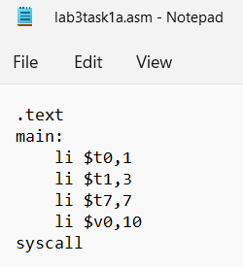

**Output:**

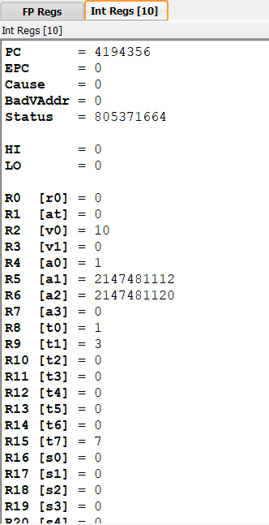

**Task 1(b):**

* **Create a program that take two integers and then find their sum.**

**Code and output:**

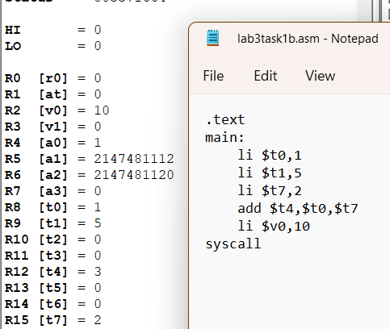

**Task 2:**

* **Create a program that take four integers and then find their sum.**

**Code and output:**

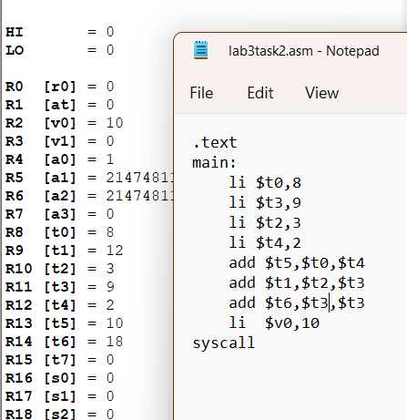

**Task 3:**

* **Create a program that take two integers from the user during run time and then find their sum.**

**code:**

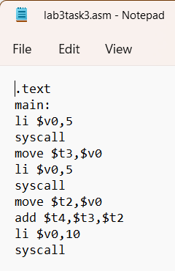

**Output:**

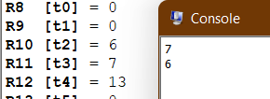

**Task 4:**

* **Create a program that take two integers from the user during run time and then find their difference.**

**Source code:**

.text

main:

li $v0,5

syscall

move $t2,$v0

li $v0,5

syscall

move $t0,$v0

sub $t1,$t2,$t0

li $v0,10

syscall

**Output:**

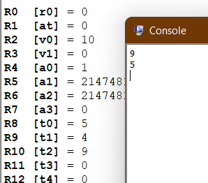

**Task 5:**

* **Create a program that take five integers from the user and perform the following operation. The output must display in console window.**

**S7=S6+S4-S5-S2+S0**

**Source code:**

.text

main:

li $v0,5

syscall

move $t0,$v0

li $v0,5

syscall

move $t1,$v0

li $v0,5

syscall

move $t2,$v0

li $v0,5

syscall

move $t3,$v0

li $v0,5

syscall

move $t4,$v0

add $s1,$t4,$t3

add $s2,$s1,$t1

add $s3,$t2,$t0

sub $s7,$s2,$s3

move $a0,$s7

li $v0,1

syscall

li $v0,10

syscall

**Output:**

